**EXPERIMENT - 1**

**AIM: Write a MATLAB/Python function that computes the value of the Gaussian distribution N(m,s) at given vector X and plot the effect of varying mean and variance to the normal distribution.**

**THEORY:**

The Gaussian (Normal) Distribution is one of the most important probability distributions in statistics and machine learning.

A random variable X follows a normal distribution with mean m (center) and standard deviation s (spread) if its probability density function (PDF) is

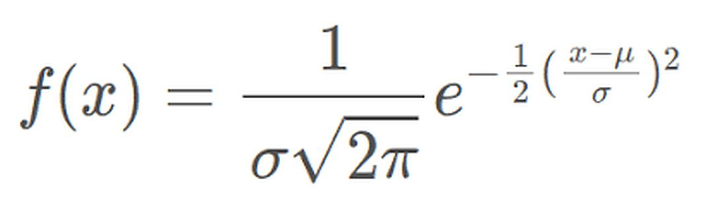

* Mean m: Determines the location of the peak.
* Standard deviation s: Determines the spread of the curve. Larger sss means flatter/wider distribution, smaller s means narrower/sharper peak.
* The curve is bell-shaped, symmetric about mmm.
* The variance is s2, measuring how spread out the data is.

Effect of parameters:

* Changing mean m shifts the curve left or right.
* Changing variance s2 changes the width and height:
* Larger variance → wider and shorter peak.
* Smaller variance → narrower and taller peak.

This makes Gaussian distribution useful for modeling natural phenomena, noise, and uncertainty.

**CODE:**

# import required libraries

import numpy as np

import matplotlib.pyplot as plt

# Gaussian Function

def gaussian(X, mean=0, sigma=1):

"""

Parameters:

X (np.array): Input points.

mean (float): Mean of the Gaussian.

sigma (float): Standard deviation of the Gaussian.

"""

coeff = 1 / (np.sqrt(2 * np.pi) * sigma)

exponent = np.exp(-((X - mean) ** 2) / (2 * sigma ** 2))

return coeff * exponent

X = np.linspace(-10, 10, 500) # creates 500 points evenly spaced between -10 and 10.

# 1. Effect of varying mean

plt.figure(figsize=(12, 5))

plt.subplot(1, 2, 1)

for m in [-3, 0, 3]:

plt.plot(X, gaussian(X, mean=m, sigma=2), label=f"μ={m}, σ=2")

plt.title("Effect of Varying Mean")

plt.xlabel("X")

plt.ylabel("Probability Density")

plt.legend()

plt.grid(True)

# 2. Effect of varying variance (sigma^2)

plt.subplot(1, 2, 2)

for s in [0.5, 1, 2, 3]:

plt.plot(X, gaussian(X, mean=0, sigma=s), label=f"μ=0, σ={s}")

plt.title("Effect of Varying Variance")

plt.xlabel("X")

plt.ylabel("Probability Density")

plt.legend()

plt.grid(True)

plt.show()

**OUTPUT:**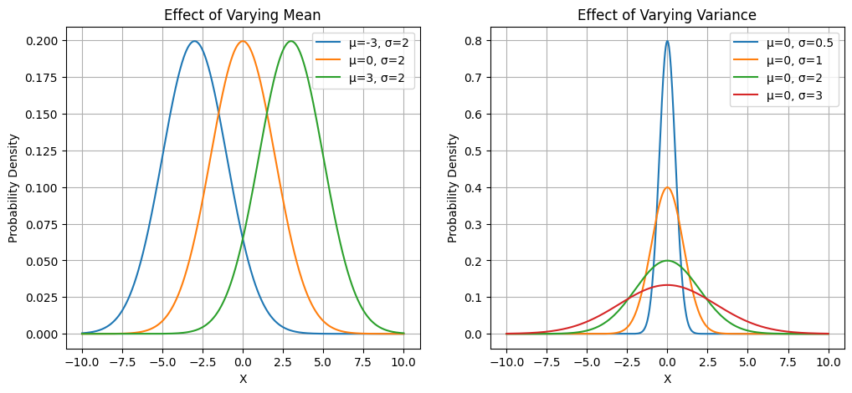

**LEARNING OUTCOME:**

**________________________________________________________________________________________________________________________________________________________________________________________________________________________________________________________________________________________________________________________________________________________________________________________________________________________________________________________________________________________________**

**EXPERIMENT - 2**

**AIM: Implementation of Gradient descent.**

**THEORY:**

Gradient Descent is an **optimization algorithm** used to minimize a cost (loss) function by iteratively updating the parameters (weights) of a model.

**The idea is:**

* + Start with some initial guess for parameters.
  + Compute the gradient (slope) of the cost function.
  + Move the parameters in the opposite direction of the gradient (because we want to minimize).
  + Repeat until convergence.
  + Update Rule:

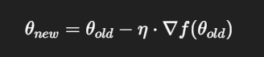

Where:

η = learning rate (step size).

∇f(θ) = gradient of the function at 𝜃

**Types of Gradient Descent**

* **Batch Gradient Descent** → uses the entire dataset for gradient calculation.
* **Stochastic Gradient Descent (SGD)** → updates parameters for each training example (faster, noisier).
* **Mini-Batch Gradient Descent** → compromise between batch and SGD (common in deep learning).

**Advantages**

* Works well for large datasets.
* General-purpose optimizer (used in ML & Deep Learning).

**Limitations**

* Choosing learning rate α is critical:
  + Too large → may overshoot and diverge.
  + Too small → slow convergence.
* Can get stuck in **local minima** for non-convex functions.

**CODE:**

import numpy as np

import matplotlib.pyplot as plt

# Function to minimize

def f(x):

return x**2 + 4*x + 5

# Gradient of the function

def grad_f(x):

return 2*x + 4 # derivative of f(x)

def gradient_descent(start_x, learning_rate, n_iter):

x = start_x

history = [x] # store values for plotting

for _ in range(n_iter):

grad = grad_f(x)

x = x - learning_rate * grad

history.append(x)

return history

# Parameters

start_x = 8 # initial guess

learning_rate = 0.1 # step size

n_iter = 25 # number of iterations

# Run gradient descent

history = gradient_descent(start_x, learning_rate, n_iter)

# Plot function and descent path

x_vals = np.linspace(-10, 10, 400)

y_vals = f(x_vals)

plt.plot(x_vals, y_vals, label="f(x) = x^2 + 4x + 5")

plt.scatter(history, [f(x) for x in history], color="red", marker="o")

plt.plot(history, [f(x) for x in history], color="red", linestyle="--", label="Descent path")

plt.title("Gradient Descent on f(x) = x^2 + 4x + 5")

plt.xlabel("x")

plt.ylabel("f(x)")

plt.legend()

plt.grid()

plt.show()

print("Final value of x:", history[-1])

print("Minimum value of f(x):", f(history[-1]))

**OUTPUT:**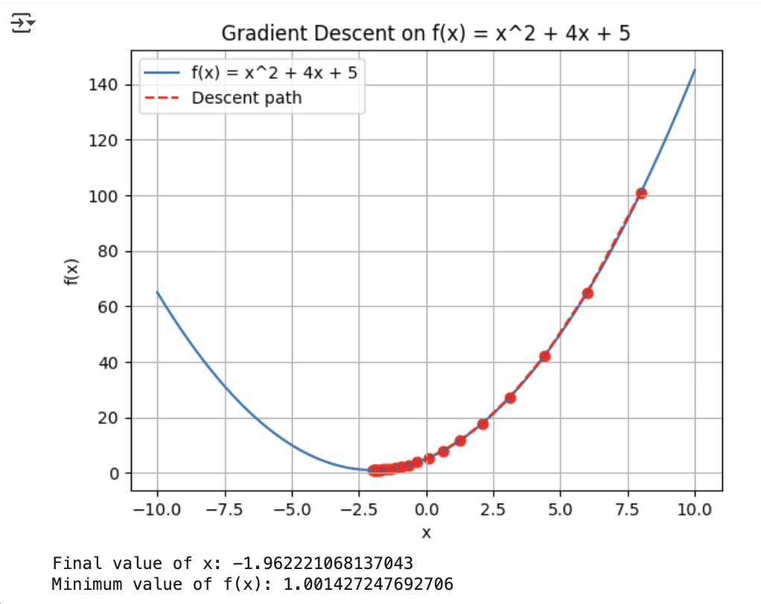

**LEARNING OUTCOME:**

**________________________________________________________________________________________________________________________________________________________________________________________________________________________________________________________________________________________________________________________________________________________________________________________________________________________________________________________________________________________________**

**EXPERIMENT - 3**

**AIM: Implementation of Linear Regression using Gradient descent.**

**THEORY:**

Linear Regression is one of the fundamental supervised learning algorithms used for predicting a continuous dependent variable based on one or more independent variables. It assumes a linear relationship between input features (X) and the target variable (Y), expressed as:

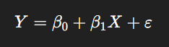

where:

* $Y$ is the dependent variable (output),
* $X$ is the independent variable (input),
* $β_{0}$ is the intercept term,
* $β_{1}$ is the coefficient (slope), and
* $ε$ represents the error term or noise.

The objective of linear regression is to find the best-fitting line (or hyperplane in higher dimensions) that minimizes the difference between the actual and predicted values of $Y$. This difference is quantified using a loss function, typically the Mean Squared Error (MSE):

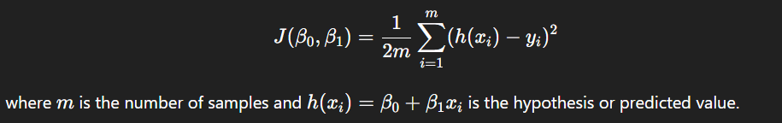

To minimize this cost function and find the optimal parameters $β_{0}$ and $β_{1}$, **Gradient Descent** 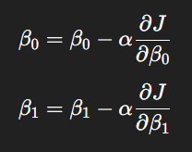is used — an iterative optimization algorithm. Gradient Descent updates the parameters in the direction of

the negative gradient of the cost function to reach the minimum point. The update rules are:

where $α$ is the learning rate, controlling the size of each step towards the minimum.

The process is repeated until convergence — i.e., until the change in cost function between iterations becomes negligibly small. Choosing an appropriate learning rate is crucial: a very large $α$ may cause divergence, while a very small $α$ can make convergence extremely slow.

Linear Regression using Gradient Descent can be extended to multiple variables (Multiple Linear Regression) by generalizing the update rules to vectors and matrices. It forms the basis for understanding more complex optimization-based machine learning algorithms, including logistic regression, neural networks, and deep learning models.

**CODE:**

import numpy as np

import matplotlib.pyplot as plt

# Dataset: Hours studied vs Score obtained

X = np.array([1.1, 2.0, 3.2, 4.5, 5.1, 6.7, 8.9, 9.2, 10.5, 11.3, 12.6, 13.1, 14.8, 15.5, 16.9])

y = np.array([17, 27, 45, 51, 62, 75, 91, 88, 96, 105, 118, 121, 135, 142, 156])

# Initialize parameters

m = 0 # slope

c = 0 # intercept

L = 0.001 # learning rate

epochs = 1000 # number of iterations

n = len(X)

# Gradient Descent

for _ in range(epochs):

y_pred = m * X + c

D_m = (-2/n) * sum(X * (y - y_pred))

D_c = (-2/n) * sum(y - y_pred)

m -= L * D_m

c -= L * D_c

# Print final parameters

print(f"Slope (m): {m:.3f}")

print(f"Intercept (c): {c:.3f}")

# Predicted values

y_pred = m * X + c

# Plot data and best fit line

plt.scatter(X, y, color='blue', label='Actual Data')

plt.plot(X, y_pred, color='red', label='Regression Line')

plt.xlabel('Hours Studied')

plt.ylabel('Score')

plt.title('Linear Regression using Gradient Descent')

plt.legend()

plt.show()

**OUTPUT:**

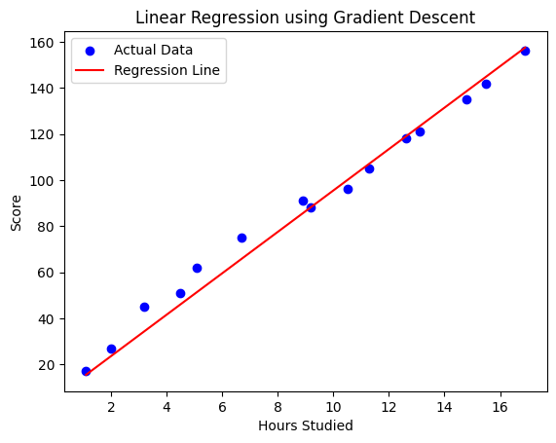

**LEARNING OUTCOME:**

**EXPERIMENT - 4**

**AIM: Comparison of classification accuracy of SVM and CNN for the dataset.**

**THEORY:**

Support Vector Machines (SVM) and Convolutional Neural Networks (CNN) are two distinct but powerful approaches to image classification.

SVM is a supervised machine learning algorithm that finds the optimal hyperplane that separates data points of different classes in a high-dimensional space. It is effective for small to medium-sized datasets and works well when features are well-engineered.

CNNs, on the other hand, are deep learning architectures inspired by the visual cortex. They automatically learn spatial hierarchies of features through convolutional, pooling, and fully connected layers. CNNs are particularly effective in extracting complex patterns from images and large-scale datasets.

While SVM relies heavily on handcrafted features, CNNs automatically learn them, leading to superior performance in modern computer vision tasks. Comparing their accuracies helps understand the trade-offs between classical machine learning and deep learning models.

**DATASET:**

**CODE:**

# Import libraries

import tensorflow as tf

from tensorflow.keras import datasets, layers, models

from sklearn import svm, metrics

from sklearn.preprocessing import StandardScaler

import matplotlib.pyplot as plt

import numpy as np

# Load MNIST dataset

(x_train, y_train), (x_test, y_test) = datasets.mnist.load_data()

# Normalize data

x_train = x_train / 255.0

x_test = x_test / 255.0

# -------------------- SVM --------------------

# Flatten images for SVM

x_train_svm = x_train.reshape(len(x_train), -1)

x_test_svm = x_test.reshape(len(x_test), -1)

# Use a smaller subset for faster SVM training

x_train_svm_small = x_train_svm[:10000]

y_train_small = y_train[:10000]

x_test_svm_small = x_test_svm[:2000]

y_test_small = y_test[:2000]

# Scale features

scaler = StandardScaler()

x_train_svm_small = scaler.fit_transform(x_train_svm_small)

x_test_svm_small = scaler.transform(x_test_svm_small)

# Train SVM

clf = svm.SVC(kernel='rbf', gamma='scale')

clf.fit(x_train_svm_small, y_train_small)

# Evaluate SVM

y_pred_svm = clf.predict(x_test_svm_small)

svm_acc = metrics.accuracy_score(y_test_small, y_pred_svm)

# -------------------- CNN --------------------

# Reshape for CNN

x_train_cnn = x_train[..., np.newaxis]

x_test_cnn = x_test[..., np.newaxis]

# Build CNN model

cnn = models.Sequential([

layers.Conv2D(32, (3,3), activation='relu', input_shape=(28,28,1)),

layers.MaxPooling2D((2,2)),

layers.Conv2D(64, (3,3), activation='relu'),

layers.MaxPooling2D((2,2)),

layers.Flatten(),

layers.Dense(64, activation='relu'),

layers.Dense(10, activation='softmax')

])

# Compile and train CNN

cnn.compile(optimizer='adam', loss='sparse_categorical_crossentropy', metrics=['accuracy'])

cnn.fit(x_train_cnn, y_train, epochs=3, batch_size=128, validation_split=0.1, verbose=2)

# Evaluate CNN

cnn_loss, cnn_acc = cnn.evaluate(x_test_cnn, y_test, verbose=0)

print(f"CNN Accuracy: {cnn_acc * 100:.2f}%")

print(f"SVM Accuracy: {svm_acc * 100:.2f}%")

# -------------------- Visualization --------------------

models_name = ['SVM', 'CNN']

accuracy_values = [svm_acc * 100, cnn_acc * 100]

plt.figure(figsize=(6,4))

plt.bar(models_name, accuracy_values, color=['skyblue', 'lightgreen'])

plt.title('Comparison of Classification Accuracy')

plt.ylabel('Accuracy (%)')

plt.ylim(0, 100)

for i, v in enumerate(accuracy_values):

plt.text(i, v + 1, f"{v:.2f}%", ha='center', fontsize=10)

plt.show()

**OUTPUT:**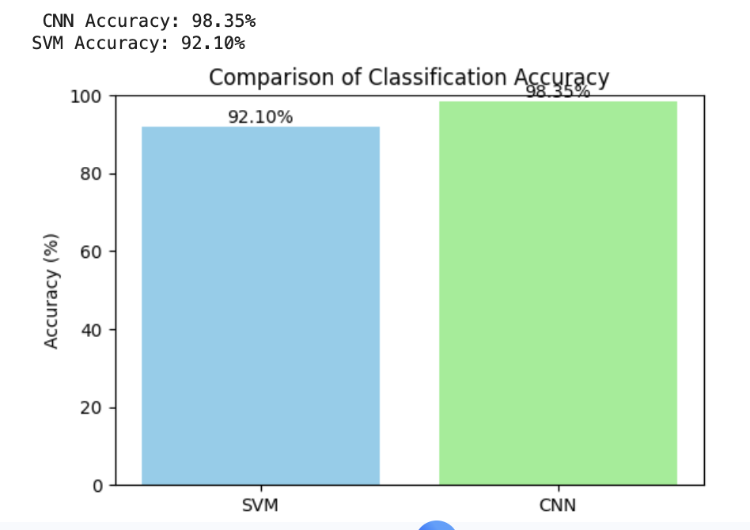

**LEARNING OUTCOME:**

**EXPERIMENT - 5**

**AIM: Implementation basic Image Handling and processing operations on the image.**

**THEORY:**

Image processing is the manipulation and analysis of visual data to extract useful information or enhance visual quality. Fundamental operations include:

* Reading and displaying images using standard libraries.
* Color space conversions, e.g., RGB to grayscale or HSV, which allow different types of analysis.
* Intensity transformations like thresholding and contrast adjustment.
* Filtering operations such as smoothing (Gaussian blur) and edge detection (Sobel, Canny).
* Morphological operations, e.g., erosion and dilation, to process binary images.

These operations form the foundation for more complex tasks like object detection, recognition, and image restoration. Understanding image representation as matrices of pixel values and performing arithmetic or logical operations is crucial in computer vision pipelines.

**CODE:**

# Import libraries

import cv2

import matplotlib.pyplot as plt

# Load and Display Image

from google.colab import files

uploaded = files.upload()

# Replace 'your_image.jpg' with the uploaded file name

image = cv2.imread(list(uploaded.keys())[0])

# OpenCV loads images in BGR format, convert it to RGB for correct display

image_rgb = cv2.cvtColor(image, cv2.COLOR_BGR2RGB)

# Display original image

plt.imshow(image_rgb)

plt.title("Original Image")

plt.axis('off')

plt.show()

# Convert to Grayscale

gray = cv2.cvtColor(image, cv2.COLOR_BGR2GRAY)

plt.imshow(gray, cmap='gray')

plt.title("Grayscale Image")

plt.axis('off')

plt.show()

# Resize and Crop

resized = cv2.resize(image_rgb, (200, 200))

cropped = image_rgb[50:250, 100:300]

plt.figure(figsize=(8,4))

plt.subplot(1,2,1)

plt.imshow(resized)

plt.title("Resized Image")

plt.axis('off')

plt.subplot(1,2,2)

plt.imshow(cropped)

plt.title("Cropped Image")

plt.axis('off')

plt.show()

# Flip and Rotate

flipped = cv2.flip(image_rgb, 1) # 1 = horizontal flip

rotated = cv2.rotate(image_rgb, cv2.ROTATE_90_CLOCKWISE)

plt.figure(figsize=(8,4))

plt.subplot(1,2,1)

plt.imshow(flipped)

plt.title("Flipped Image")

plt.axis('off')

plt.subplot(1,2,2)

plt.imshow(rotated)

plt.title("Rotated Image (90°)")

plt.axis('off')

plt.show()

# Blurring (Smoothing)

blurred = cv2.GaussianBlur(image_rgb, (9,9), 0)

plt.imshow(blurred)

plt.title("Gaussian Blurred Image")

plt.axis('off')

plt.show()

**OUTPUT:**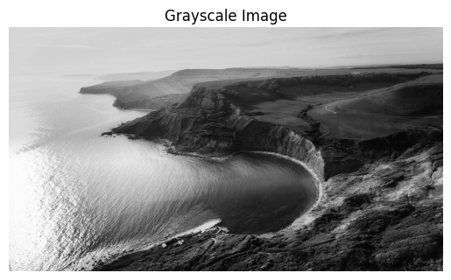

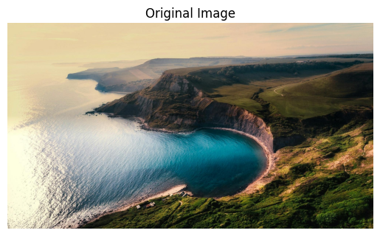

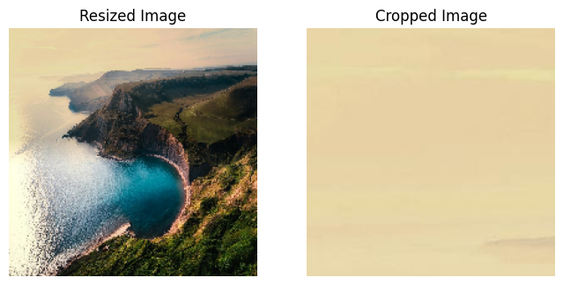

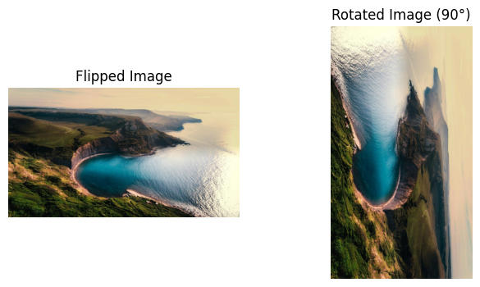

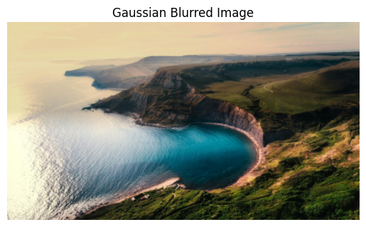

**LEARNING OUTCOME:**

**EXPERIMENT - 6**

**AIM: Implementation of Geometric Transformations**

**THEORY:**

Geometric transformations modify the spatial arrangement of pixels in an image while preserving its structure. They are used for tasks such as image registration, alignment, and augmentation.

* Common transformations include:
* Translation, shifting the image in x or y directions.
* Scaling, resizing the image.
* Rotation, turning the image around a pivot point.
* Reflection, flipping the image along an axis.

Mathematically, geometric transformations can be represented using homogeneous coordinates and transformation matrices, allowing multiple transformations to be combined into a single operation. Understanding geometric transformations is essential for correcting distortions and aligning images in computer vision systems.

**CODE:**

import cv2

import numpy as np

import matplotlib.pyplot as plt

from google.colab import files

# Upload image

uploaded = files.upload()

image = cv2.imread(list(uploaded.keys())[0])

image_rgb = cv2.cvtColor(image, cv2.COLOR_BGR2RGB)

# Display original image

plt.imshow(image_rgb)

plt.title("Original Image")

plt.axis('off')

plt.show()

rows, cols = image.shape[:2]

# Translation

tx, ty = 50, 30

translation_matrix = np.float32([[1, 0, tx], [0, 1, ty]])

translated = cv2.warpAffine(image_rgb, translation_matrix, (cols, rows))

plt.imshow(translated)

plt.title("Translated Image")

plt.axis('off')

plt.show()

# Scaling

scaled = cv2.resize(image_rgb, None, fx=1.5, fy=1.5, interpolation=cv2.INTER_LINEAR)

plt.imshow(scaled)

plt.title("Scaled Image")

plt.axis('off')

plt.show()

# Rotation

center = (cols // 2, rows // 2)

rotation_matrix = cv2.getRotationMatrix2D(center, 45, 1.0)

rotated = cv2.warpAffine(image_rgb, rotation_matrix, (cols, rows))

plt.imshow(rotated)

plt.title("Rotated Image (45°)")

plt.axis('off')

plt.show()

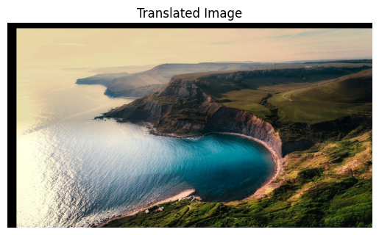

**OUTPUT:**

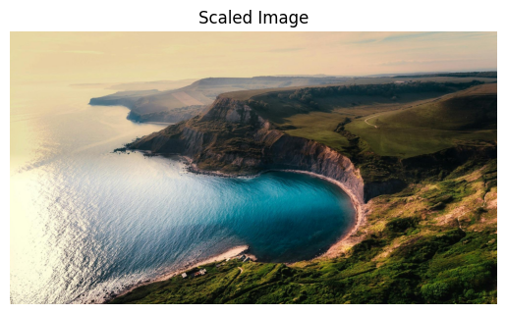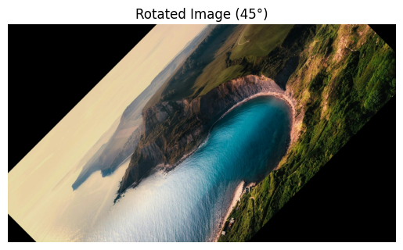

**LEARNING OUTCOME:**

**EXPERIMENT - 7**

**AIM: Implementation of Perspective Transformation.**

**THEORY:**

Perspective transformation (also called projective transformation) is used to map an image from one plane to another, preserving straight lines but altering angles and distances. It models the way a camera views a 3D scene on a 2D image plane.

Perspective transformation is represented by a 3x3 homography matrix that maps points (x,y) in the source image to points (𝑥′,𝑦′) in the destination image. This transformation is widely used for:

* Correcting perspective distortions in images of buildings or documents.
* Creating bird’s-eye views in robotics and autonomous driving.
* Image stitching in panorama generation.

This technique demonstrates the geometric relationship between images and real-world structures, bridging image processing with projective geometry concepts.

**CODE:**

import cv2

import numpy as np

from google.colab import files

from matplotlib import pyplot as plt

# Upload image

uploaded = files.upload()

# Read uploaded image

image_path = list(uploaded.keys())[0]

img = cv2.imread(image_path)

img = cv2.cvtColor(img, cv2.COLOR_BGR2RGB)

# Display original image

plt.imshow(img)

plt.title('Original Image')

plt.axis('off')

plt.show()

# Define 4 source points (from image)

pts1 = np.float32([[100, 100], [400, 100], [100, 400], [400, 400]])

# Define 4 destination points (desired view)

pts2 = np.float32([[50, 150], [450, 100], [150, 450], [400, 400]])

# Compute perspective transform matrix

matrix = cv2.getPerspectiveTransform(pts1, pts2)

# Apply perspective warp

output = cv2.warpPerspective(img, matrix, (img.shape[1], img.shape[0]))

# Display transformed image

plt.imshow(output)

plt.title('Perspective Transformed Image')

plt.axis('off')

plt.show()

**OUTPUT:**



**LEARNING OUTCOME:**

**EXPERIMENT - 8**

**AIM: Implementation of Camera Calibration**

**THEORY:**

Camera calibration is the process of estimating the internal parameters (intrinsic) and external parameters (extrinsic) of a camera to relate 3D world coordinates to 2D image coordinates.

Intrinsic parameters include focal length, principal point, and lens distortion coefficients, while extrinsic parameters define the camera’s position and orientation in the world. Calibration uses images of known patterns (like a chessboard) to solve equations mapping 3D points to their 2D projections.

Accurate camera calibration is critical for applications such as 3D reconstruction, robotics, augmented reality, and stereo vision, where precise measurements of real-world geometry from images are required.

**CODE:**

import numpy as np

import cv2

import glob

from google.colab.patches import cv2_imshow

# Prepare object points (0,0,0), (1,0,0), ..., (8,5,0)

objp = np.zeros((6*9, 3), np.float32)

objp[:, :2] = np.mgrid[0:9, 0:6].T.reshape(-1, 2)

objpoints = [] # 3D points in real world

imgpoints = [] # 2D points in image plane

# Path to chessboard images

# (upload to your Google Drive or /content folder)

images = glob.glob('/content/drive/MyDrive/images/calibrationImages/*.jpg')

# Detect corners in all images

for fname in images:

img = cv2.imread(fname)

gray = cv2.cvtColor(img, cv2.COLOR_BGR2GRAY)

ret, corners = cv2.findChessboardCorners(gray, (9, 6), None)

if ret:

objpoints.append(objp)

imgpoints.append(corners)

cv2.drawChessboardCorners(img, (9, 6), corners, ret)

cv2_imshow(img)

# Camera calibration

ret, mtx, dist, rvecs, tvecs = cv2.calibrateCamera(objpoints, imgpoints, gray.shape[::-1], None, None)

print("Camera matrix:\n", mtx)

print("\nDistortion coefficients:\n", dist)

**OUTPUT:**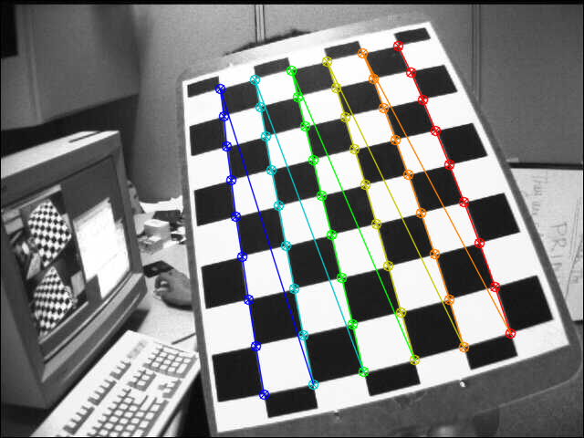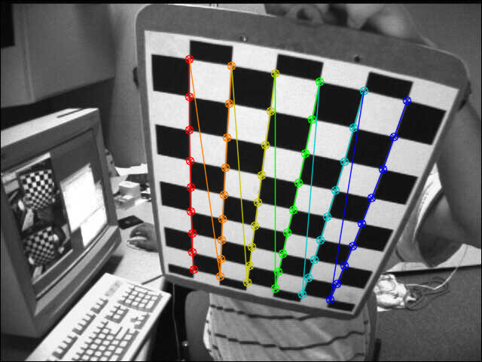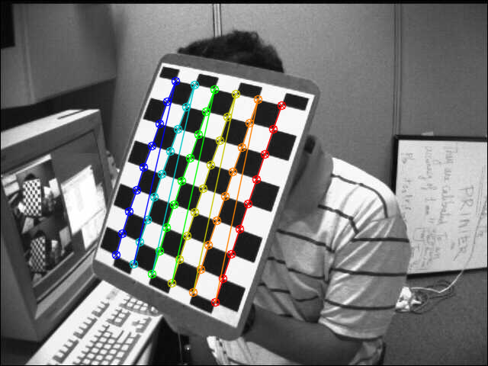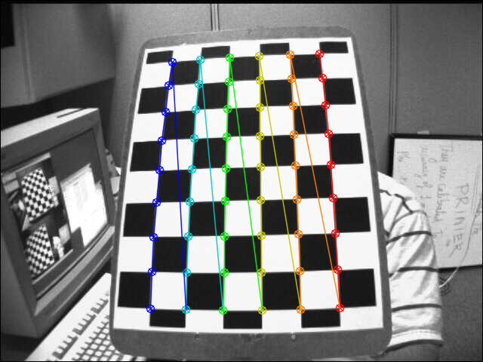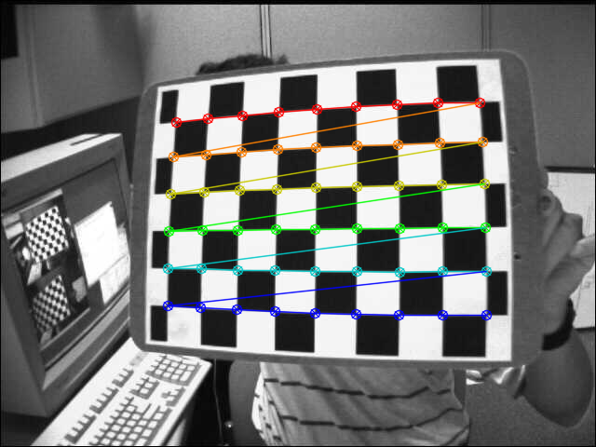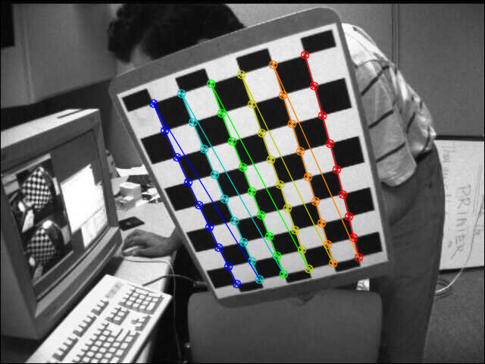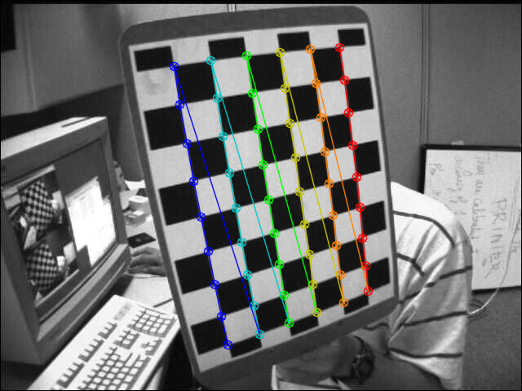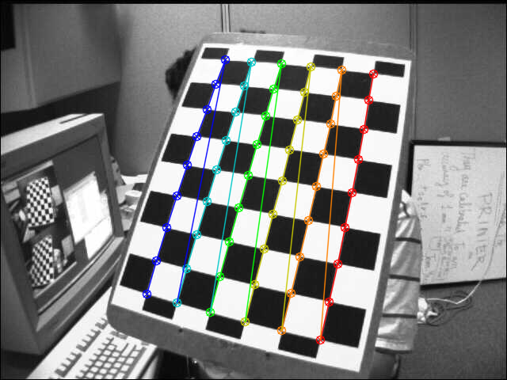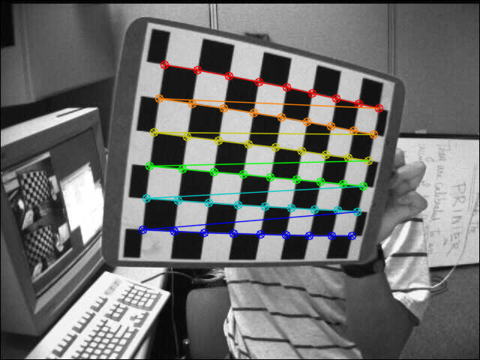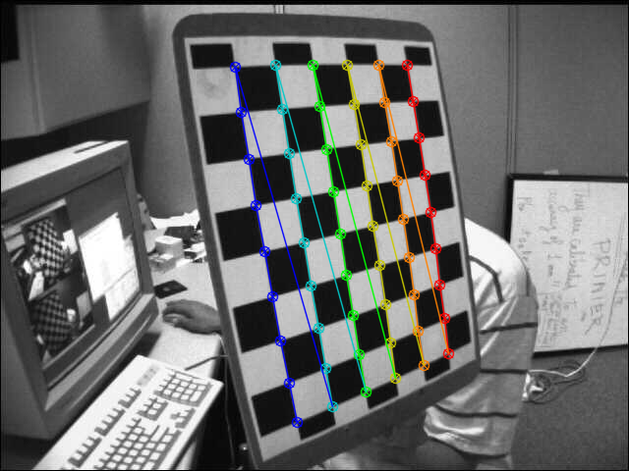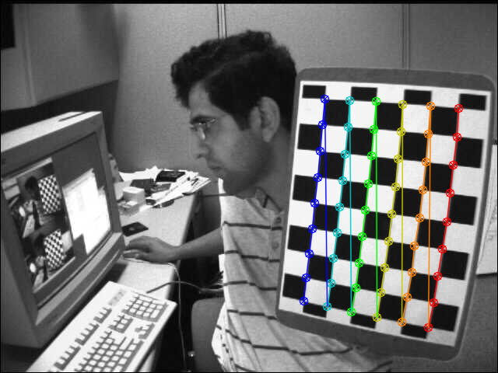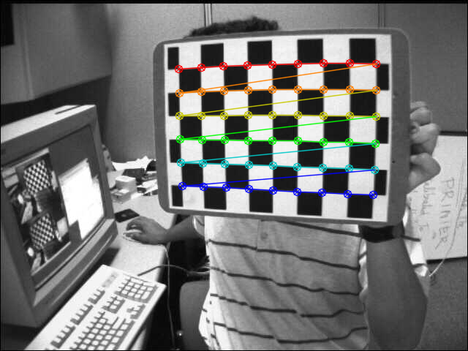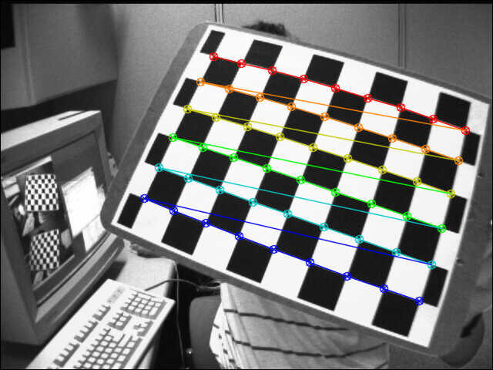

**LEARNING OUTCOME:**

**EXPERIMENT - 9**

**AIM: Compute Fundamental Matrix.**

**THEORY:**

In stereo vision, the fundamental matrix F encodes the epipolar geometry between two camera views. It maps points in one image to corresponding epipolar lines in another image, constraining the search for corresponding points along lines rather than the entire image plane.

Mathematically, for corresponding points 𝑥 and 𝑥′ in homogeneous coordinates:

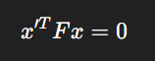

The fundamental matrix can be estimated from a set of corresponding points between two images using algorithms like the 8-point algorithm. It is central to tasks like 3D reconstruction, depth estimation, and motion analysis, providing the geometric relationship between multiple views of a scene.

**CODE:**

import cv2

import numpy as np

from google.colab.patches import cv2_imshow

# Load stereo pair images (left and right)

img1 = cv2.imread('/content/drive/MyDrive/images/calibrationImages/left01.jpg', 0)

img2 = cv2.imread('/content/drive/MyDrive/images/calibrationImages/right01.jpg', 0)

# Check if images loaded correctly

if img1 is None or img2 is None:

raise ValueError("❌ Could not load the stereo images. Check your file paths!")

# Detect SIFT keypoints and descriptors

sift = cv2.SIFT_create()

kp1, des1 = sift.detectAndCompute(img1, None)

kp2, des2 = sift.detectAndCompute(img2, None)

# Match descriptors using Brute Force matcher

bf = cv2.BFMatcher(cv2.NORM_L2, crossCheck=True)

matches = bf.match(des1, des2)

# Sort matches based on distance (best matches first)

matches = sorted(matches, key=lambda x: x.distance)

# Extract point coordinates from matches

pts1 = np.float32([kp1[m.queryIdx].pt for m in matches])

pts2 = np.float32([kp2[m.trainIdx].pt for m in matches])

# Compute the Fundamental Matrix using RANSAC

F, mask = cv2.findFundamentalMat(pts1, pts2, cv2.FM_RANSAC)

print(" Fundamental Matrix (F):\n", F)

# Draw top 30 matches

img_matches = cv2.drawMatches(img1, kp1, img2, kp2, matches[:30], None, flags=2)

cv2_imshow(img_matches)

**OUTPUT:**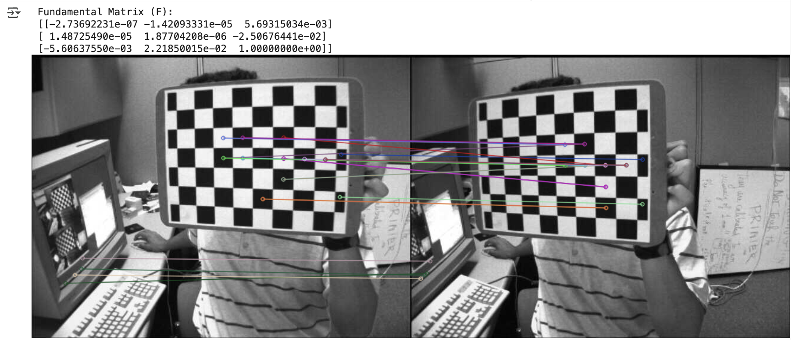

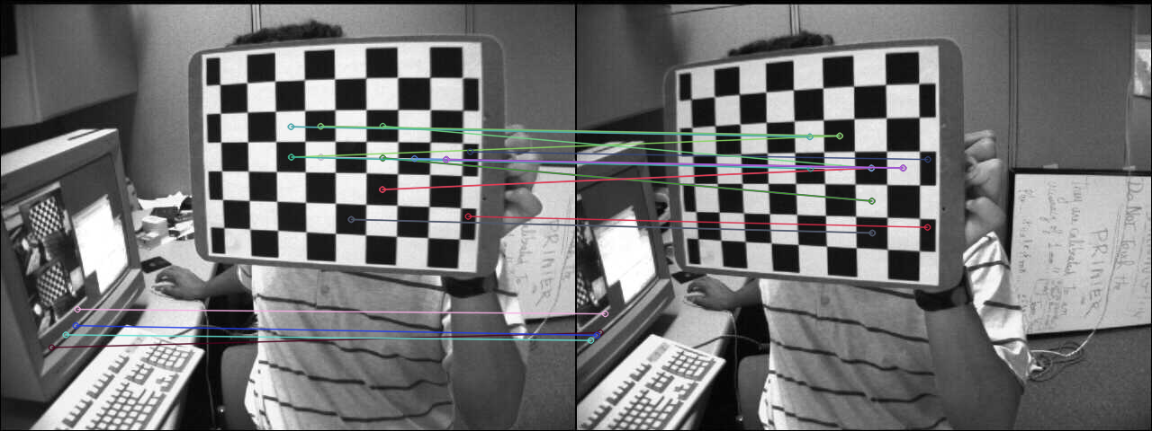

**LEARNING OUTCOME:**